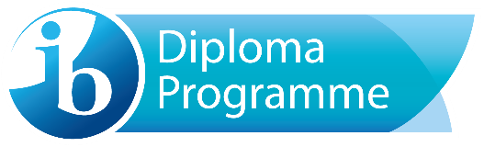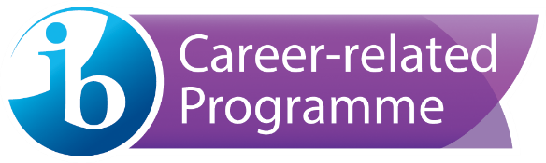

West Hall High School IB Admissions Policy

The West Hall High International Baccalaureate Programme is open to highly motivated, academically focused students who meet selective admissions criteria. Beginning in the middle grades, students learn about the IB programme at WHHS when the IB coordinator along with the I squared and World Scholars coordinators visit WMS and DVA in the spring of their 8th grade year. In addition to that, 10th graders attend IB information sessions with current IB students and the IB coordinator to learn about IBDP, IBCP, bilingual options, and coursework and determine what option would be best suited for them. The local school news promotes IB during the year so that students are aware of the application process. Parents are informed via the school webpage and remind accounts that the application is available. Students who are interested in the programme will apply via a Canvas course that is available on the school webpage in January of their 10th grade year. The application includes teacher recommendations, a short essay, and a transcript of 9th and 10th grades. In the spring of their sophomore year, a review of the student’s transcripts, recommendations, and goals will complete the application process. Students may be asked to interview with a committee to determine their motivation and suitability to the IB Programme as well as to determine the best programme for them (IBDP, IBCP, bilingual, course). Students formally begin the IB Programme in the fall of their junior year. Taking Honors and AP classes helps students prepare for the IB curriculum, but there are no required Honors/AP classes or required GPA. What is most important is a student’s desire to move beyond the college-prep curriculum to a more rigorous and interdisciplinary course of study. Successful students are motivated, committed, and demonstrate excitement about thinking and learning.

- The Diploma Programme (IBDP) is a two-year academically challenging programme of education that prepares student for success at university and life beyond. It is designed to address the intellectual, social, emotional, and physical well-being of students. Students enroll in 6 IB courses, and complete service learning through CAS (creativity, activity, and service), write an Extended Essay in a topic of their choice, and complete the Theory of Knowledge course.

- Bilingual Diploma Programme: WHHS also offers a track for students to earn the prestigious IB Bilingual Diploma. Native speakers of Spanish or fluent speakers of Spanish may apply to take Spanish A: Language and Literature in combination with English B or English A. Students who are most likely to be successful are those who exhibit a high degree of Spanish literacy. Admissions criteria for this track are the same as for the DP; however, scores on Native Speaker tests and personal interviews are taken into account by the Bilingual Diploma Coordinator to determine the level of literacy.

- The Career-Related Programme (IBCP) is an internationally recognized program that offers you the flexibility to take two, three, or four, rigorous IB classes and continue to focus on your career pathway in Healthcare, Marketing, Graphic Arts, or Audio-Visual. You can pursue a challenging academic program that will help prepare you for college and your future career. The career-related programme will aid in developing practical problem solving, ethical understandings, responsibility, resilience, and skills needed to successfully navigate higher education and the workplace. In addition, students who are fluent in Spanish may also pursue the prestigious IBCP bilingual certificate.

Preparation: To prepare for the IB Coursework, students can take the Honors and AP classes in 9th and 10th grade. Students can also take high school level classes at West Hall Middle School in 7th and 8th grades.

Philosophy: West Hall prides itself on inclusivity and recognizes that there are many students who may not appear to be obvious IB candidates on paper, but who exhibit aspects of the IB learner profile. We seek to assess the student as a whole in terms of teacher recommendations, grades, essays, assessment history, and interviews, so that we can make the best recommendation for future student success.

