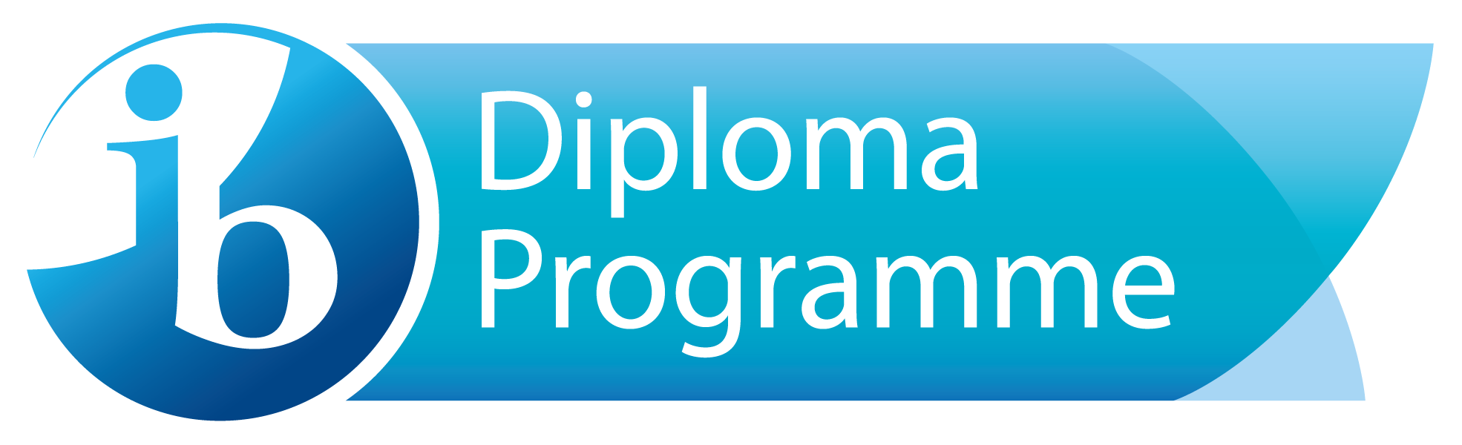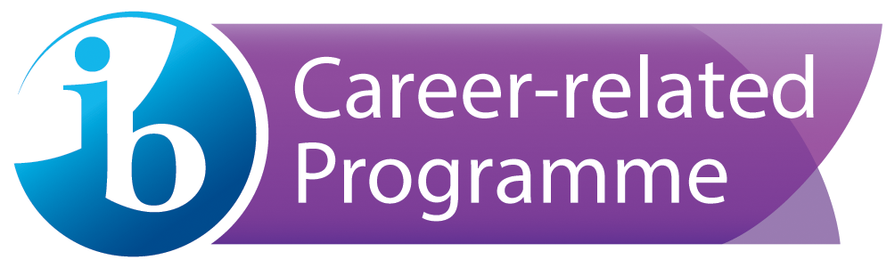

West Hall High School IB Assessment Policy

West Hall High School uses diagnostic, formative, and summative assessments to support and improve student learning. In the International Baccalaureate Program at WHHS, assessments are criterion-referenced according to specific criteria published by IB. Each subject is supported by guides, rubrics, and mark bands that measure and inform student success. In addition to the guidelines provided by IB, teachers differentiate assessments according to the needs of their students so that students with various learning styles are able to be successful in this highly rigorous program.
Purposes of Assessment:
- To provide consistent and frequent feedback to students about how they are meeting the expectations of state standards
- To provide consistent and frequent feedback to students about how they are meeting the expectations of IB standards
- To provide feedback to teachers on student progress
- To provide feedback to parents through progress reporting
- To provide quality assurance
- To condition students mentally for the rigors of IB exams

Summative Assessment in the DP Program
The most important aim of assessment in the International Baccalaureate Diploma Programme is to support learning goals by measuring student understanding based on the whole course and the ability to recall, adapt and apply knowledge and skills to new contexts. The IBO, therefore, places more value on providing multiple opportunities for demonstrating acquired knowledge or skills in order to gain an accurate measure of student success. For this reason, formal summative assessment in the IB Diploma Programme is comprised of internal assessments, which are graded by the teacher according to IB assessment criteria while moderated by the IBO, and external assessments which are scored by the IBO.
- Internal Assesments (IAs): The International Baccalaureate prescribes various internal assessments for each subject. These internal assessments vary in number according to subject and are designed to allow for students to demonstrate a degree of learner autonomy through choice of topic, methodology, and production while seeking to meet the criteria prescribed by IB. The Internal Assessments are graded by teachers according to the IB rubric; however, samples (about 10%) of student work are sent to IB for moderation. These IAs combine with grades achieved on external assessments to form a student’s overall IB score.
- External Assessments: External assessments for each IB subject, which are scored by IB examiners, are given in May of senior year. The number of exams per subject varies. Higher level subjects tend to have more assessments than Standard level subjects. Full diploma students must take 3 HL classes and 3 standard level, each in a different subject. The table below describes the HL and SL offerings at West Hall High School.
Higher Level (HL) | Standard Level (SL)
English Literature | Spanish A Language and Literature
English B (bilingual diploma) | Spanish B
History of the Americas | Mandarin ab initio
Psychology | Biology
Theater | Math SL or Math Analysis
Visual Arts | Math Studies or Math Applications

- Earning the Diploma: For each subject, internal components as well as external components combine to form a score of 1-7 with 7 being the highest. A student’s score in each subject will determine whether they earn college credit according to each college or university’s transfer credit policy. Furthermore, a student must score a total of 12 points in HL (Higher Level) classes and 9 points in SL classes in order to achieve a combined score of 24 points in order to earn the IB Diploma.
Theory of Knowledge and the Extended Essay also contribute to a candidate’s total score in that each are graded on a scale of A (maximum) to E (minimum). For the IB Diploma, a maximum of 3 points is awarded for combined performance in Theory of Knowledge and the Extended Essay. The maximum total of points a student could score is 45.
In addition to the criteria listed above, IB diploma candidate students participate in Creativity, Activity, and Service (CAS). In their CAS portfolio, they will demonstrate evidence of achieving 7 learning outcomes over the course of two years.
The IB publishes assessment criteria for each of its externally moderated exams as well as the internal assessments. It is expected that teachers communicate these criteria to students early in the curriculum and model their assessments on these criteria.
For specific information regarding the percent value of each IA and EA please refer to each subject teacher’s syllabus posted on his or her website.
- Earning the Career-Related Certificate: Similar to “Earning the Diploma” above, each subject, internal component as well as external components combine to form a score of 1-7 with 7 being the highest. A student’s score in each subject will determine whether they earn college credit according to each college or university’s transfer credit policy. Each IBCP student must take a minimum of 2 IB courses and score a minimum of 3 on at least two IB courses.
The Personal and professional skills (PPS) course is designed for students to develop attitudes, skills and strategies to be applied to situations now and in the future. In this course, students will also receive support to help complete their reflective project, language portfolio, and service learning hours or CAS.

Successful completion of a career pathway is an essential component of the IBCP. To fulfill the state of Georgia pathway requirements, students must complete three specific courses in a pathway and take the EOPA (end-of-pathway assessment). If successful, students will earn an industry credential.

Diagnostic and Formative Assessment in the DP program
The West Hall High School IB program implements a variety of diagnostic and formative assessment strategies to measure and inform student success.
IB summative assessments (external and internal) are criterion-related rather than norm-referenced, which means they measure students success in terms of identified levels of attainment rather than in relation to other students. It is therefore expected that teachers will develop formative assessments that will help achieve these levels of attainment in the learning process. To this end, every IB teacher undergoes IB training to ensure that they are developing formative assessments that prepare students for IB exams (external assessments). Formative assessments in the IB diploma program emphasize helping students to judge their progress through teacher-supported self-evaluation and the regular use of rubrics published by the IBO. Other strategies include: class discussions, field work, essays, oral presentations, projects, research papers, Investigation workbooks, historical investigations, individual oral commentaries, multimedia presentations, etc. A variety of assessment strategies are used to reduce disadvantages, allowing a range of opportunities for students to be successful. The overall goal of these formative strategies is to empower the student to be his or her own judge of progress through providing them the resources to do so, essentially helping students learn how to learn.
Standardization of Assessment and Teacher Collaboration
It is important for IB assessment practices to be standardized according to IB protocols. Teacher collaboration, therefore, is essential in providing assessment structures for students to achieve their learning goals, especially in cases where a two year subject is taught by more than one teacher. For this reason, the school allows scheduling time for teachers to collaborate so that the experience and results of IB assessment do not vary according to classroom.
Grades (Recording and Reporting)
Teachers base their major assessment grades (including the Internal Assessments) on IB grade boundaries, converting the IB 1-7 scale to a percentage. These major assessment grades are then entered into the student’s WHHS gradebook on Infinite Campus. Minor assessments may or may not follow the IB grade boundaries. Students and parents may then check the Infinite Campus portal for grade reports.
Homework
Homework guidelines are varietal per content area. They are specific to task, unit, and standard being addressed within each unit.
Scheduling of Assessments
The West Hall High School IB program takes care to schedule internal assessments so that deadlines are evenly distributed over the course of the two year program. The schedule of assessments are distributed via monthly calendars. The school also designates certain days of the week for formative assessment deadlines so that students do not become over-burdened. In 2018-2019, WHHS adopted a modified block schedule which aids in the distribution of assessments.
West Hall IB and State/Federal Requirements
IB students must fulfill state and federal requirements in order to graduate with a high school diploma. If a student has not had American Literature, both English A Literature (first year) and English B (second year) may substitute for that course. In this case, students must take the End of Course Test in those classes. Likewise, the first year of IB History of the Americas may substitute for U.S. History.

