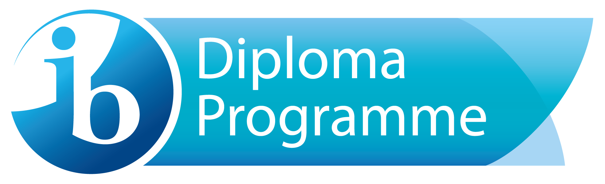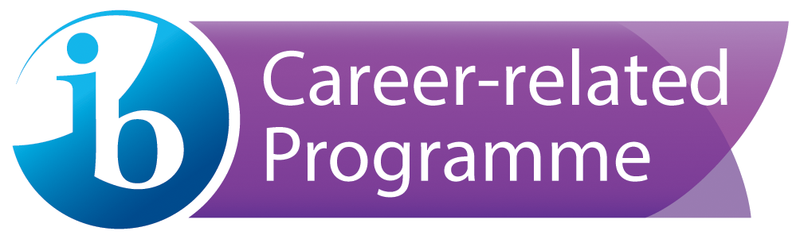

West Hall High School IB Language Policy

“The International Baccalaureate is committed to supporting multilingualism as fundamental to increasing intercultural understanding and international-mindedness, and is equally committed to extending access to an IB education for students from a variety of cultural and linguistic backgrounds.”
IB Language Policy Document, February 2014
Leaders in Hall County Schools recognize a need to prepare all students to compete in a global economy by increasing its number of bilingual graduates. In addition to providing cognitive benefits and increased problem-solving skills, bilingualism supports improved cultural and linguistic understanding that will be needed in our increasingly interconnected world.
At West Hall High School, all teachers regardless of their specific content area, are considered language teachers, communicating and facilitating the exchange of information across different cultural and linguistic paradigms. Though English and Spanish comprise the majority of student languages in the WHHS language profile, students speaking Vietnamese, Korean, Bosnian, French, Kurdish and Amharic have all found language support at WHHS. WHHS’ language policy reflects the research findings that full development of mother tongue skills is essential to students’ intellectual abilities. We are also cognizant of the multiple benefits of knowing and using a second language.
To this end, all college preparatory students at WHHS are expected to learn 2 years of a foreign language, as it is a prerequisite for admissions to college. Within the International Baccalaureate program, the response language in which IB students engage in internal or external assessment is English, except of course for Group 2 language acquisition courses such as Spanish or Chinese where the response language is the language of instruction. Students who are Native speakers of Spanish taking Spanish A: Language and Literature also respond in Spanish. Group 1 Literature courses include English A: Literature, Spanish A: Language and Literature, and Self-taught Language A for students wishing to study literature in their native tongue (other than Spanish or English). Group 2 Language courses include English, Spanish, and Chinese. Students in our IB Career Programme are required to complete a language portfolio where they document their language learning over two years in IB.

Group 1 | English A: Literature  Spanish A: Language and Literature  Self-taught Language A
Group 2 | Spanish B  Spanish ab initio  English B  Mandarin ab initio

Support for the Mother Tongue:
At West Hall High School, support for the mother tongue is an integral part of school culture. Since the majority of students are native speakers of English and Spanish, news announcements and signage are conducted in both Spanish and English. Meetings with stakeholders are regularly held in bilingual format. The school retains a bilingual parent liaison who helps to translate and communicate with parents. Additionally, bilingual instruction is available in various classrooms depending on the language profile of the students and teacher. The World Scholars Program, a 9th and 10th grade program which feeds the International Baccalaureate program, offers science and social studies taught in Spanish in order to accommodate students who have experienced language immersion education prior to high school or are native speakers of Spanish.
The West Hall International Baccalaureate program offers every IB student the opportunity to cultivate strong critical reading, writing, thinking and presentational skills in their native language. Additionally students are required to develop active skills in a second language: Our group 1 offerings in English, Spanish and other tongues (self-taught Language A) are complemented by Group 2 courses in English, Spanish and Chinese.
Support for the mother tongue is further exemplified by our IB Bilingual Diploma Programme. West Hall High School offers Spanish A Literature to our Native Speakers of Spanish who may then also take either English A Literature or English B. Since these students who are taking Spanish A/English B are taking the majority of their classes in English, WHHS provides extra support for them within the curriculum of the English B classroom—support for their main subjects, the Theory of Knowledge, Creativity Action and Service, Extended Essay, and college admission.
Furthermore, the WHHS IB Programme supports the native tongue of students whose languages are not represented in our course list by offering a chance to earn the bilingual diploma through Self-taught Language A. Examples of this option have included Bosnian, French, Korean, and Amharic.

Reading Support for Native Speakers
IB students who are native speakers of Spanish may encounter difficulty in classes that require heavy reading in English. As a result, the school provides support for these students through the use of supplementary reading guides and Spanish to English dictionaries. Students have access to authentic literature and technology resources to enhance their language skills. Other strategies for supporting these students include electronic tools such as Cornell notes, NewsELA, and Quizlets.
Inclusion and Equity of Access
Although the working language of WHHS is primarily English, the IB program is promoted to the entire community of stakeholders in both Spanish and English. To this end, the school translates its International Baccalaureate application into Spanish, copies of which are available in the IB Coordinator’s office. The school does not require specific pre-requisites to enter the IB program but admits students based on application criteria. To ensure equity of access to the IB full diploma program in terms of language proficiency, the school offers ab initio language options where appropriate.
Native speakers of Spanish and English may take literature and AP language courses in those tongues prior to enrolling in the IB program. For Native speakers of languages other than Spanish we offer IB Language A self-taught. In the past we have offered Bosnian, French, Amharic, and Korean.
Expectations of IB Language Profile Development
In the West Hall High School International Baccalaureate program it is expected that:
- Teachers will implement strategies developed during collaborative planning to assist English language learners in being successful in the program.
- Administrators, teachers, and media specialists will be familiar with the language policy as a working document and will undergo professional development in the field of language learning and ELL support.
- Teachers will implement strategies to support students’ acquisition of a second language.
- Teachers will meet regularly to discuss the success of those strategies.
- Students will be invested in the value of multilingualism and will complete a language profile survey at the end of each semester.
- Parents will show investment in their students’ language profile by completing a language profile survey with their students at the end of every semester. The school’s bilingual parent liaison will help with this process.
- School-supported self-taught language options will be provided where appropriate
- Ab initio and B options for languages will be offered when appropriate
- IBCP students will complete a language development portfolio over documenting their growth over the course of two years.

Language Policy as a Working Document
- The language policy will be reviewed every year during pre-planning for the purpose of serving changing demographics.
- Teachers will be reminded of WIDA ELL standards on a yearly basis and collaborate concerning best practices for ELL support.
- The language policy will inform any changes in West Hall High School’s admissions or assessment policies to reflect changing demographics.
- The Language Policy and any updates to the Language Policy will be presented to faculty at meetings and communicated to stakeholders through the school’s website.

