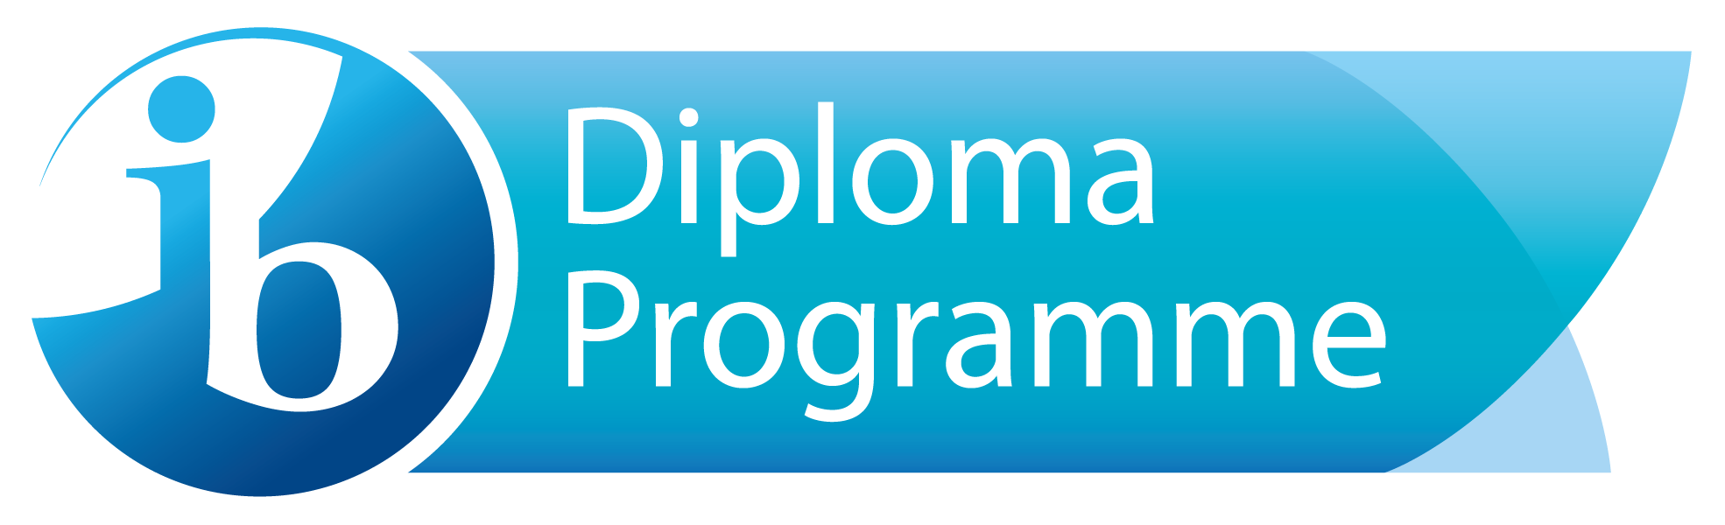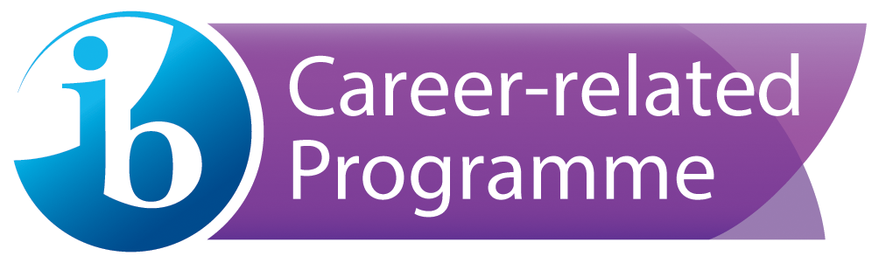

West Hall High School IB Special Education Needs Policy

Philosophy
The West Hall International Baccalaureate Diploma and Course programme has a strong history of supporting special education needs. We believe that in an IB World School, all students should have access to an international education. We are also firmly dedicated to the notion that our IB student body should reflect a wide range of learning styles. In the West Hall IB family of learners, special needs students feel welcomed and supported by both teachers and fellow students. The decision to grant students with special need access to the IB curriculum is based on considerations by the parent, teacher, administrators, and the lead special education teacher. IB classes will then maintain an appropriate level of support as decided by the parents and school, keeping in line with stipulations written into an Individual Education Plan or 504.
Admission
The admission process for special needs students is the same as for any student (see WHHS Admission Policy). Special needs students who wish to study in the IB family of learners are encouraged to apply according to the WHHS IB admissions process. When the student’s application is analyzed in terms of teacher recommendation and academic history, the IB coordinator and Special Needs teacher will meet with parents and the student to determine an appropriate course of study and the appropriate teaching modifications that should be implemented in the classroom.
Classroom Support
Teachers of special needs students in the West Hall IB program will maintain a positive learning environment which balances a realistic sensibility with the appropriate level of challenge. Teachers will incorporate any modifications listed on an IEP, as well as any strategies that are developed through collaboration with other teachers in order to help the student navigate the high standards of the IB curriculum. To this end, teachers will include the students in decisions about their learning, document progress, and celebrate success so that they come to understand themselves as confident learners.

Monitoring
IB students who are served under an Individual Education Plan or a 504 plan are given equal access into any program available at WHHS as long as they meet the entrance requirements of the program. Students who are served under a 504 plan have at least a yearly conference to determine what modifications are necessary for students to be successful in the classroom. The 504 Coordinator monitors the student’s progress throughout the year and determines if other team meetings are necessary to revisit the student’s accommodation needs.
Students who are served thorough an IEP also have an annual meeting to determine the least restrictive environment for learning. Other conferences are scheduled as well to discuss transition plans, educational goals and progress monitoring. West Hall High school offers a variety of Special Education services for students served with an IEP.
- Direct Instruction
- Co-teaching model
- Supportive Instruction
- Consult Services
- Speech, Hearing, Vision
Most of the IB students who are served under an IEP need fewer accommodations and are served through Supportive Instruction or Consult Services.
Assessment
The following is quoted from the International Baccalaureate Diploma Programme Assessment procedures 2020:
“The IB believes that all candidates must be allowed to take their examinations under conditions that are as fair as possible. Where standard examination conditions and assessment procedures would put candidates at a disadvantage and prevent them from being able to demonstrate their skills and knowledge adequately, reasonable forms of access arrangements may be authorized.

Candidates may need access arrangements due to learning support requirements such as:
- learning disabilities
- specific learning difficulties
- communication and speech difficulties
- autism spectrum disorders
- social, emotional and behavior challenges
- medical and mental health difficulties, including temporary medical conditions
- additional language learning” *
*IB Diploma Programme Assessment procedures 2020, page 121
In accordance with IB and West Hall policy, the school has acquired and implemented testing modifications for special needs students who have earned the IB diploma as well as IB certificates. Once a special needs student enters the second year of the program (senior year), the school sends a request for testing modifications to IB with supporting evidence in order to acquire the appropriate modifications for external exams in May.

